Examen IIB Marcos Quichimbo

* Backend
  + controllers

Producto.controller.js

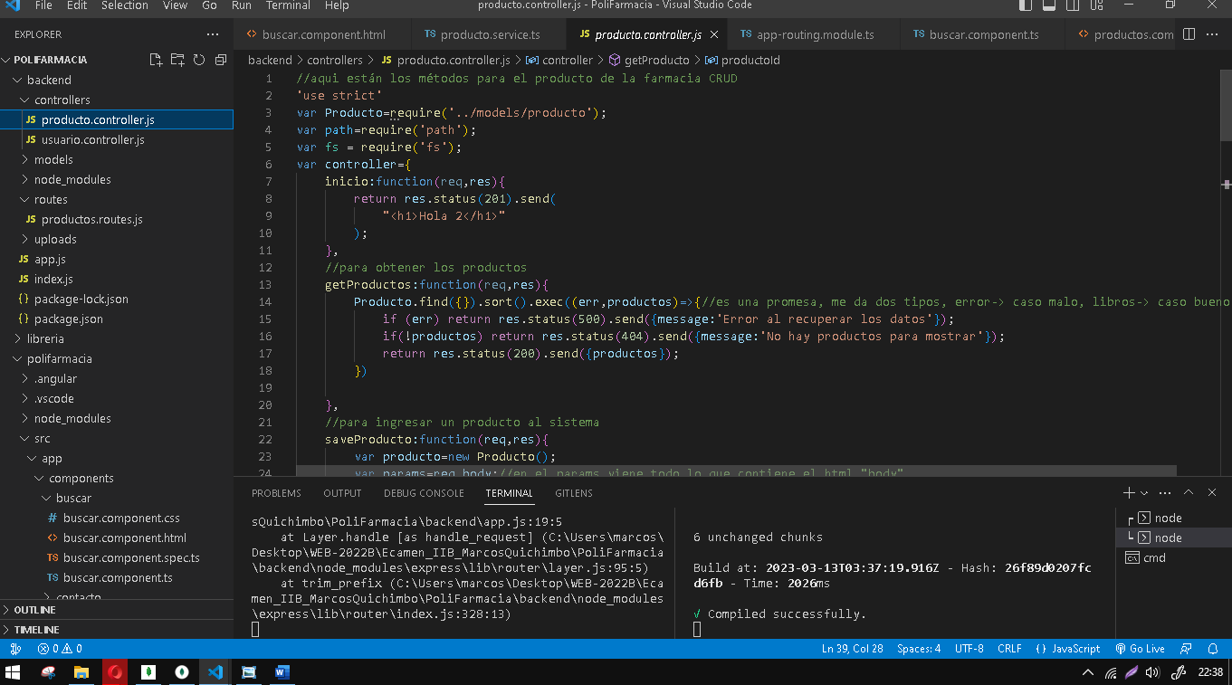

Usuario.controller.js

* models

producto.js

Usuario.js

* routes

producto.routes.js

Index.js

* fronend
  + componentes

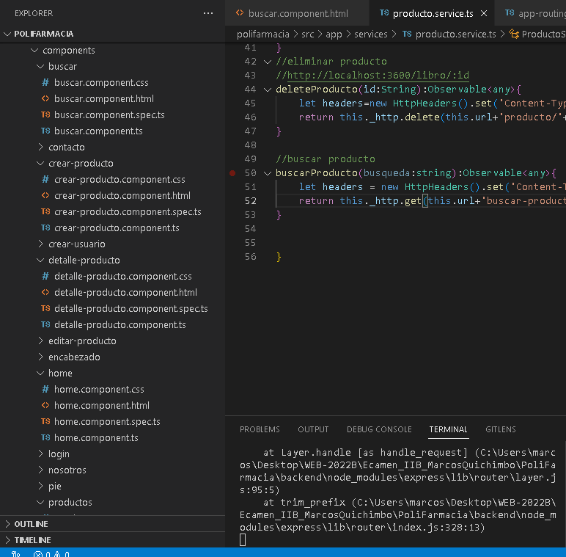

Buscar. Components.html

Buscar.components.ts

Contacto.component.html

Contacto.component.ts

crear-producto.component.html

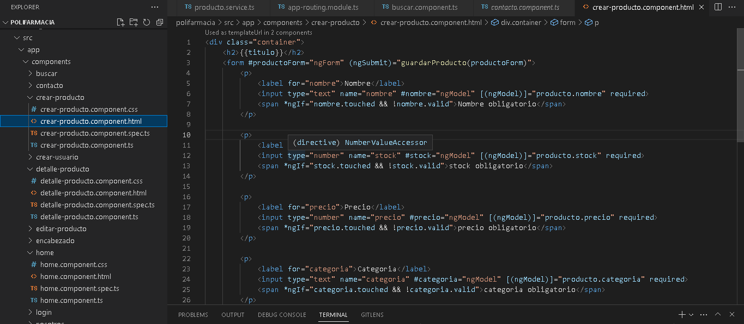

crear-producto.component.ts

crear-usuario.component.html

crear-usuario.component.ts

detalle-producto.componetn.html

detalle-producto.componetn.ts

Model

Producto.ts

Usuario.ts

Services

Cargar.services.ts

Global.ts

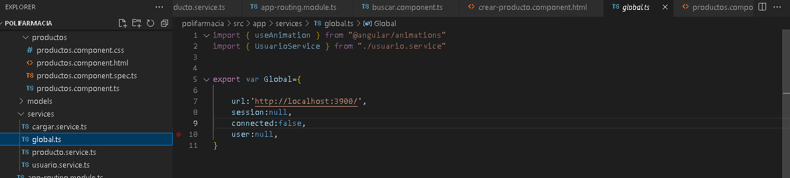

Producto.services.ts

Usuario.services.ts

App-routing.module.ts

App.component.html

App.component.ts

App.modules.ts

Aplicativo

INICIO

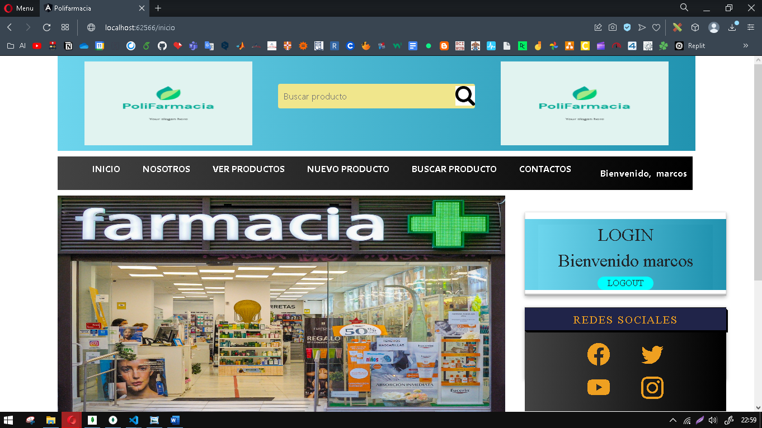

NOSOTROS

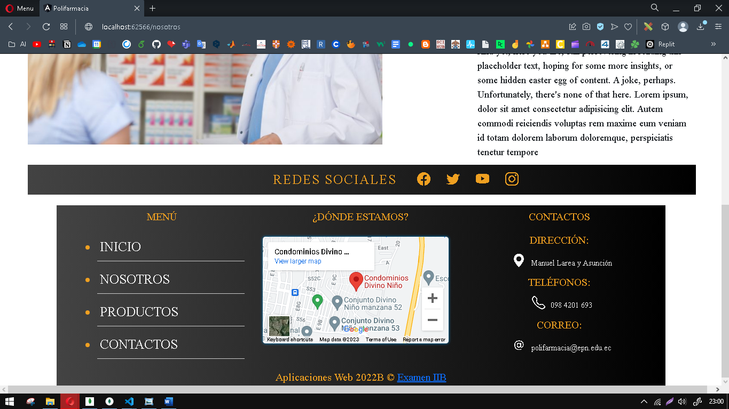

VER PRODUCTOS

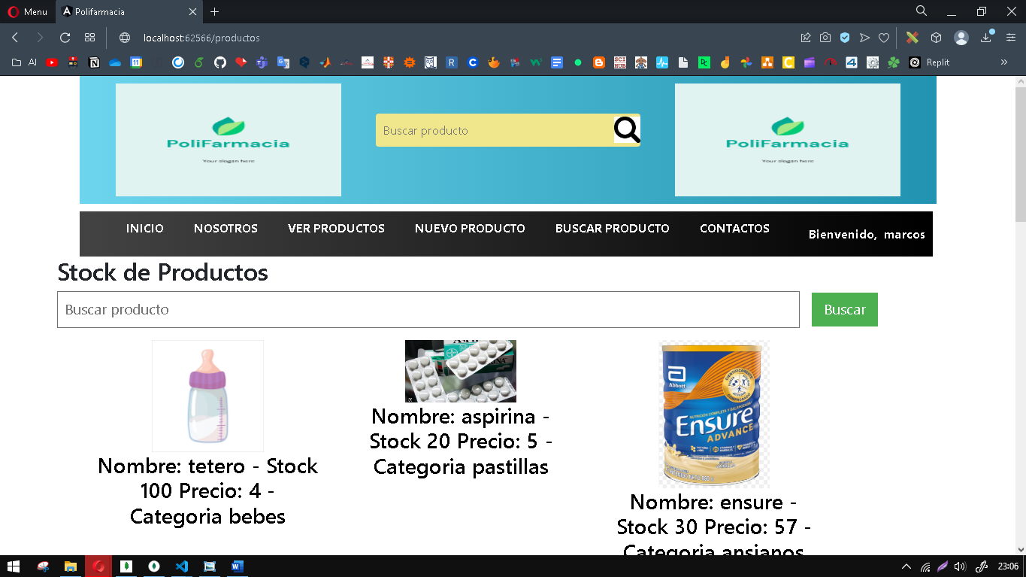

NUEVO PRODUCTO

BUSCAR PRODUCTO

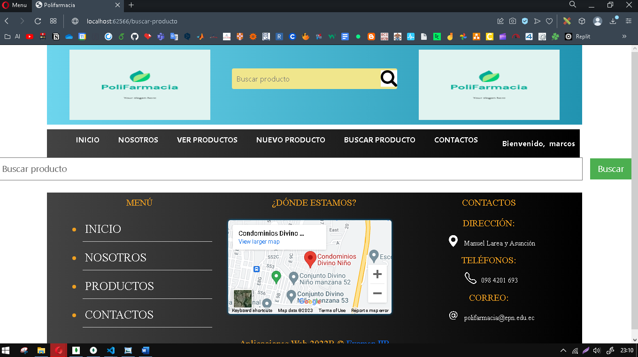

CONTACTO

LOGIN

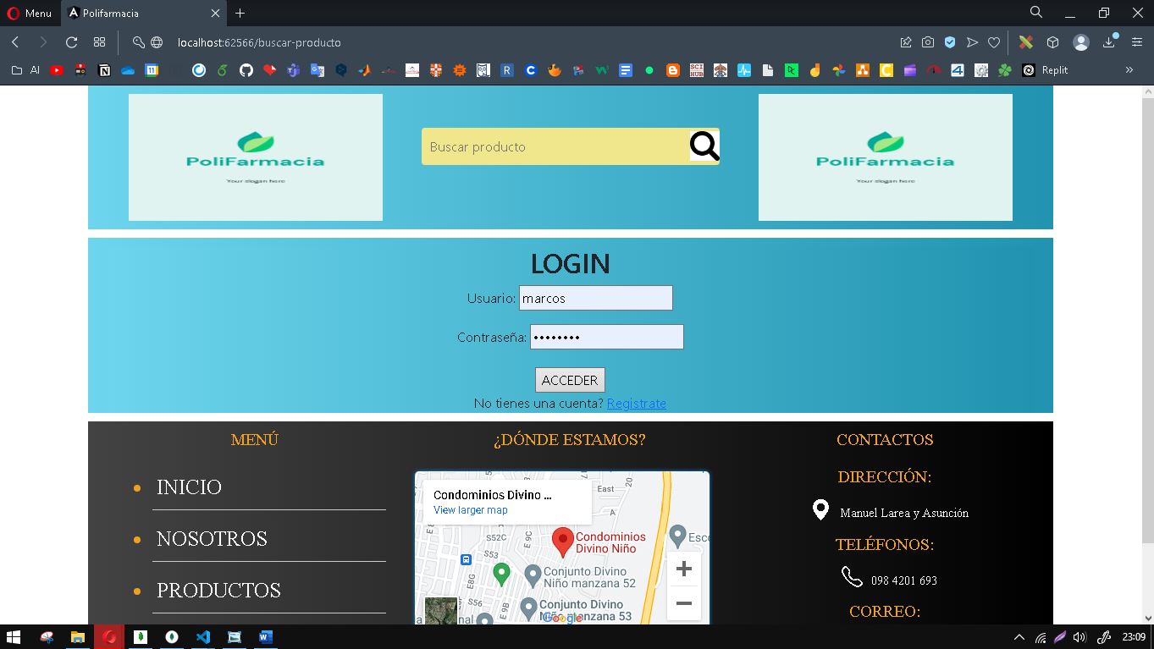

REGISTRO

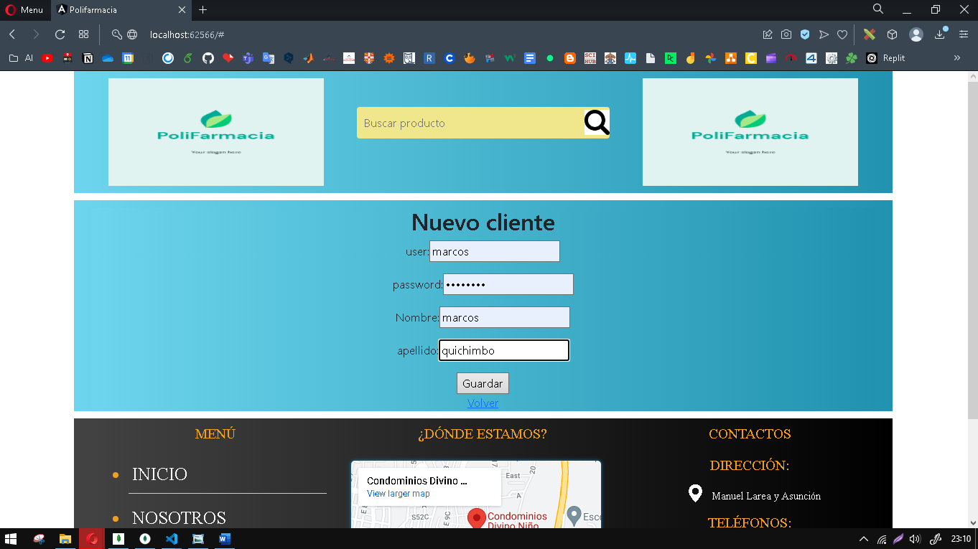

Mongo

Usuarios

